BL

Class Objectives

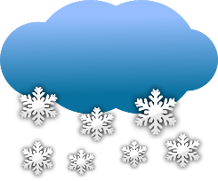
2-18

Remember FEME are due!

1st year students
~ Complete FER: Learning Styles
~ Complete Learning Styles Activity
~ Complete Personal Learning Style Poster
~ Contemplate SHINE nomination (due this week)
~ Complete MI of the Famous
~ Complete MI worksheet
Remember Field Trip Permission Form
~ Begin EIN: Teen Brain

2nd year students
*** Field Experience ***

